ЧЕТВЕРГ – 23.04 Аудирование:
- Libraries are useful both for adults and kids.
- Libraries currently need more financial support.
- The library is a perfect place for work and study.
- Libraries provided everyone with equal opportunities.
- Social work of libraries bring benefits to the communities.
- The digital age is replacing libraries with new devices.
- The competence of the staff varies from library to library.
A | B | C | D | E | F

2.
- Sean has been studying Greek since he was 4.
- Sean keeps his favourite book near his bed.
- Jinny has chosen a story for the competition.
- Jinny is skeptical about the idea of the competition.
- Jinny is good at drawing posters.
- The competition involves staging a play at the theatre.
- Jinny thinks they have enough time to prepare.
A | B | C | D | E | F | G

3. When is Jacky’s birthday? 1) today 2) tomorrow 3) on Wednesday
4. Which is TRUE about Jacky and her husband? 1) they’ve been married for 75 years 2) they both like coconut cakes 3) they are the same age
5. When she was a teenager, Jacky helped her mom 1) sell subscriptions to the newspapers 2) write news about WW II 3) do what she was asked to
6. At the end of the war Jacky’s husband found himself in 1) Sussex 2) Tennessee 3) the Far East
7. How many years did Jacky write for the newspaper? 1) 25 2) 33 3) 84
8 Jacky’s fans liked reading her column because it 1) covered different topics 2) was written in an authoritative tone 3) gave an honest point of view
9. During the meeting of the board of directors, Jacky used to 1) listen to others rather than speak 2) ask many questions 3) make everyone do what she wants
Чтение (10) :

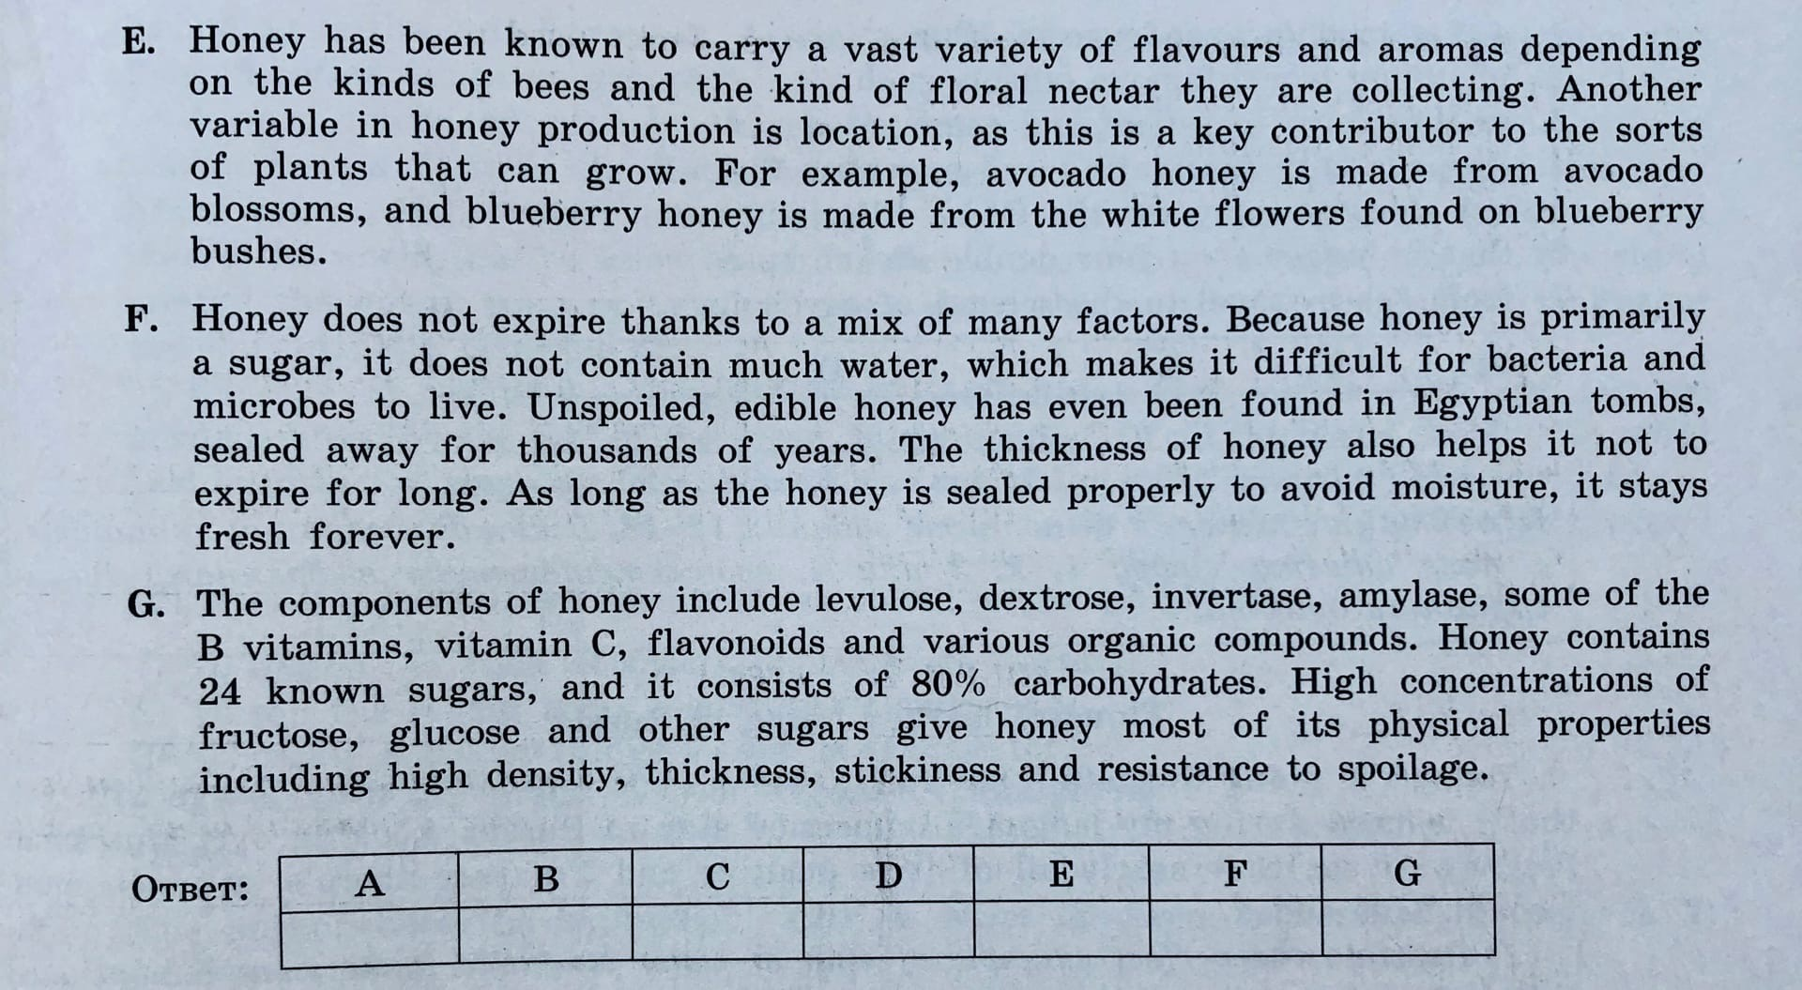

Чтение (11):
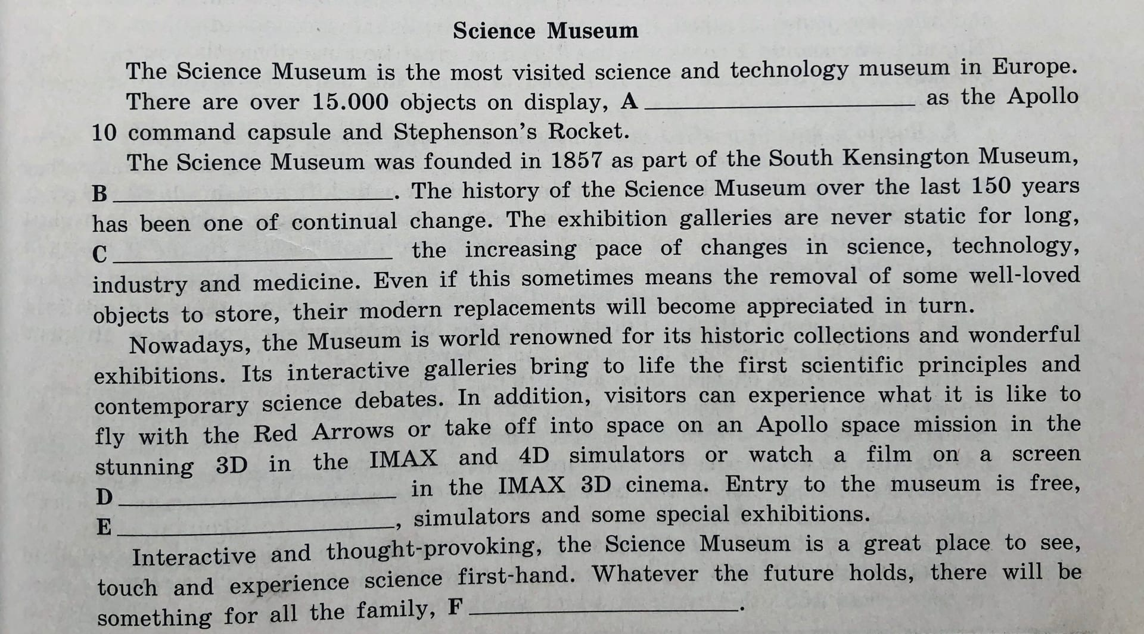
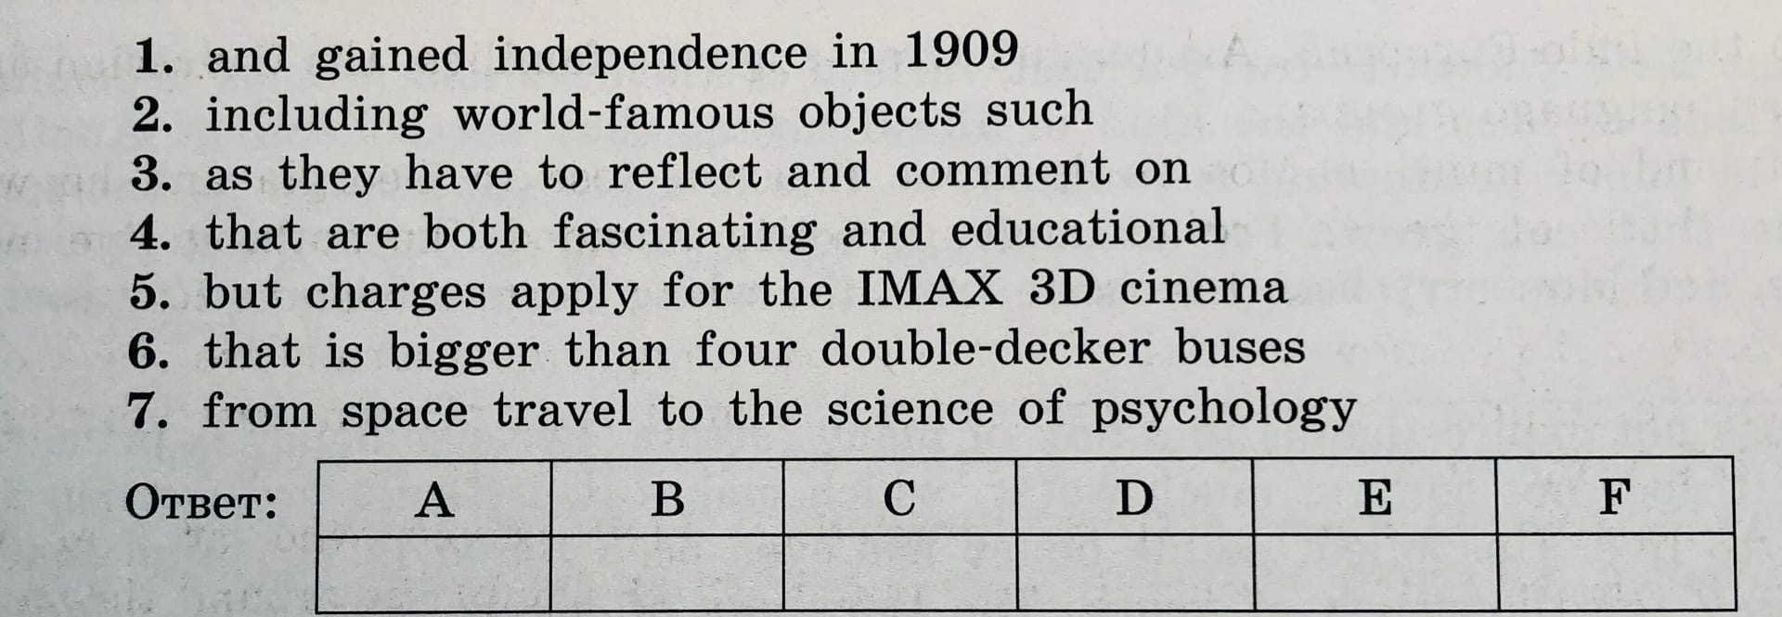

Чтение (12-18):
