ЧЕТВЕРГ – 30.04 Аудирование (В 11):
- I believe many people misunderstand fashion.
- I must have enough clothes to choose from.
- Clothes make you look your best.
- Thinking about fashion is a waste of time.
- I’m sure clothes should be practical.
- You and people around you should feel good about what you wear.
- Parents often criticize fashion choices of their children.
A | B | C | D | E | F

2.
- Michael isn’t enjoying his studies.
- Jane is free on Saturday evening.
- Michael’s favourite actor is Michael Douglas.
- Jane agrees to go to the cinema.
- Shops in bath are less expensive than shops in Clifton.
- There are several good restaurants in the new shopping mall in Bath.
- Michael and Jane will go to Bath by car.
A | B | C | D | E | F | G

3. Why does Mariela think that the first question is easy?
1) The answer depends on her mood
2) The choice of films is limited
3) She has her personal favourite
4. Why does Mariela name “American Beauty” the best film?
1) Because of acting
2) Because it’s mainstream
3) Because of its plain plot.
5. Why is “Gladiator” not Mariela’s favourite film?
1) It’s too mysterious
2) For her it’s a usual film
3) It’s not exciting
6. Mariela thinks that “The Sixth Sense” was
1) made by the best director
2) the most unanticipated success
3) made to frighten people
7. According to Mariela, what is good about “All about my Mother”?
1) It has a lovely beginning and sad ending
2) There are more positive feelings in it
3) It can touch feelings of anybody
8. What does Mariela say about John Travolta in “Pulp Fiction?”
1) His role was not typical of him
2) He could play any part in it
3) He’s the best as a bad guy
9. What does Mariela think about “Chicago”?
1) It’s the best musical ever
2) The choice of the actors determined its success
3) This musical is not for the cinema
Чтение (В11-10) :
- Food: eating habits
- Entertainment with vegetables
- Food: its features
- Entertainment with animals
- Population
- Time to relax
- With nature
- Spain as a state
- A unique food battle festival known as La Tomatina is celebrated in Spain every year on the last Wednesday of August. It involves thousands of people engaging in a brutal battle, throwing overripe tomatoes at each other. The festival spans more than a week and although there are many elements to the festival, such as parades, music, dancing and fireworks, they are all centered on the tomato fight.
- Spanish cuisine is a heavenly mixture of chicken, mixed vegetables, fish and meats. Many of the most popular Spanish dishes are a type of Paella, which is a rice dish that features a variety of ingredients. Hot chocolate and churros are very popular desserts throughout the country. Spain is also famous for its aromatic wines and other alcoholic beverages like Sangria, Cava and authentic Spanish beer.
- Spain is very rich with traditions, especially those associated with food. For breakfast, some families buy fresh curros, pair them with hot chocolate and enjoy a leisurely morning routine. Lunch is another important meal of the day, and it is usually heavier than breakfast. This is sometimes followed by a siesta, an afternoon nap to get through post-lunch drowsiness. During this time, shops close and then open again after two or three hours of rest.
- Spain is an important resting spot for migratory birds and a home for many animals. But, unfortunately, many species of wildlife face threats from habitat loss and pollution. Due to centuries of tree cutting, large forests are now found only in a few area in the country. Spain has created many national parks and refuges, but they cover only about seven percent of the country.
- Although there is a national parliament, Spain is one of the most decentralized democracies in Europe. Each of its 17 regions manages its own schools, hospitals, and other public services. The tourists services drives Spain’s economy, but at the same time, since 1986, when Spain joined the European Community, it has worked to diversify its economy, by building important industries such as mining, shipbuilding, and textiles.
- Bullfighting is one of the most famous traditions in Spain. This risky sport evolved from the ancient Roman gladiator games, with human matadors opposing charging bulls. However, this tradition has lately become widely debated and younger generations and animal-rights activists protest against bullfighting. Either way, it remains an iconic part of the country and bullfights take place in many Spanish towns and cities.
- La siesta is a well-known aspect of Spanish culture. Seeking to balance work with pleasure, Spaniards have long practiced this tradition, when students and professionals return to their homes around midday for a big lunch, followed by a few hours of rest and family time. Many businesses also shut down for a short break. However, 21st-century big cities move at a faster pace, and don’t take siestas, but many people in smaller towns and villages still take a siesta each day.
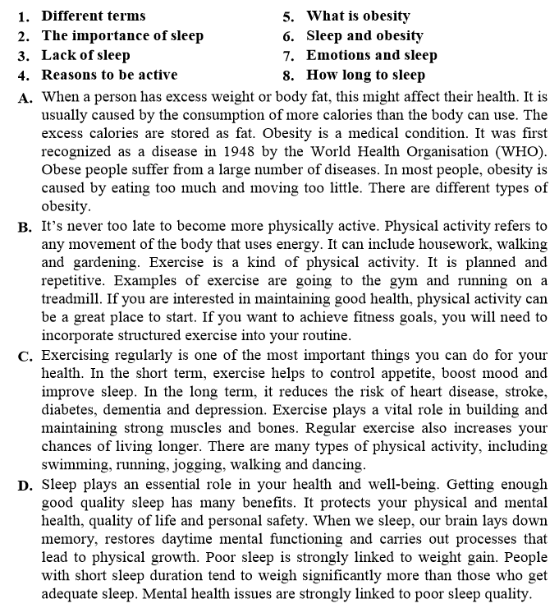
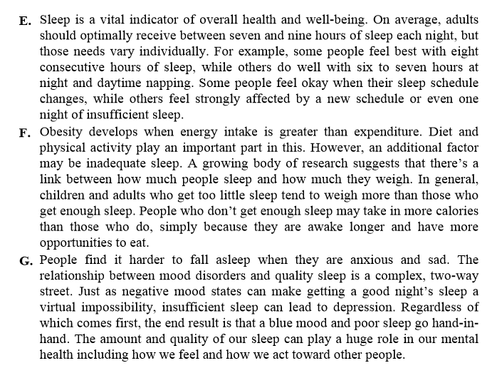
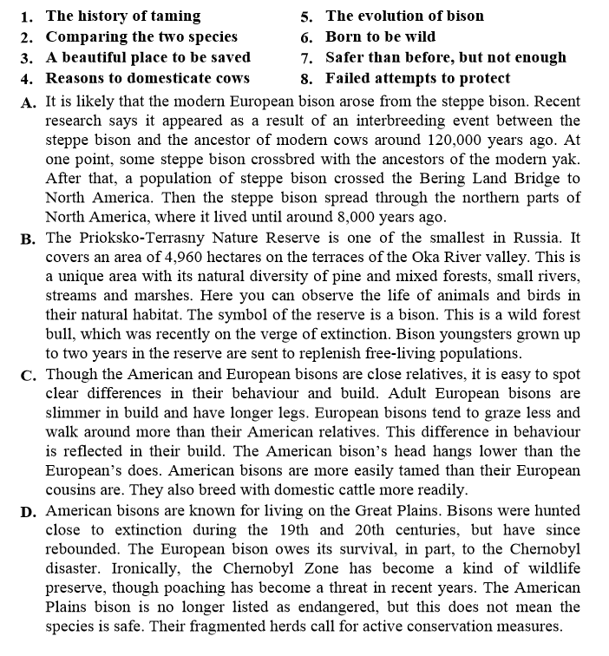
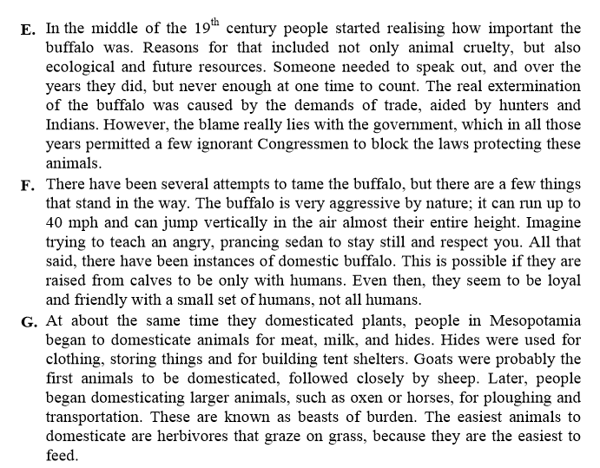

Чтение (12-18):
